ASSINGMENT – 24

Code:

create or replace procedure raise_sal(p_id in empl.emp_id%TYPE,p_percent in number) is

begin

update empl set net_sal=net_sal*(1+p_percent/100) where emp_id=p_id;

end;

begin

raise_sal(103,10);

end;

/

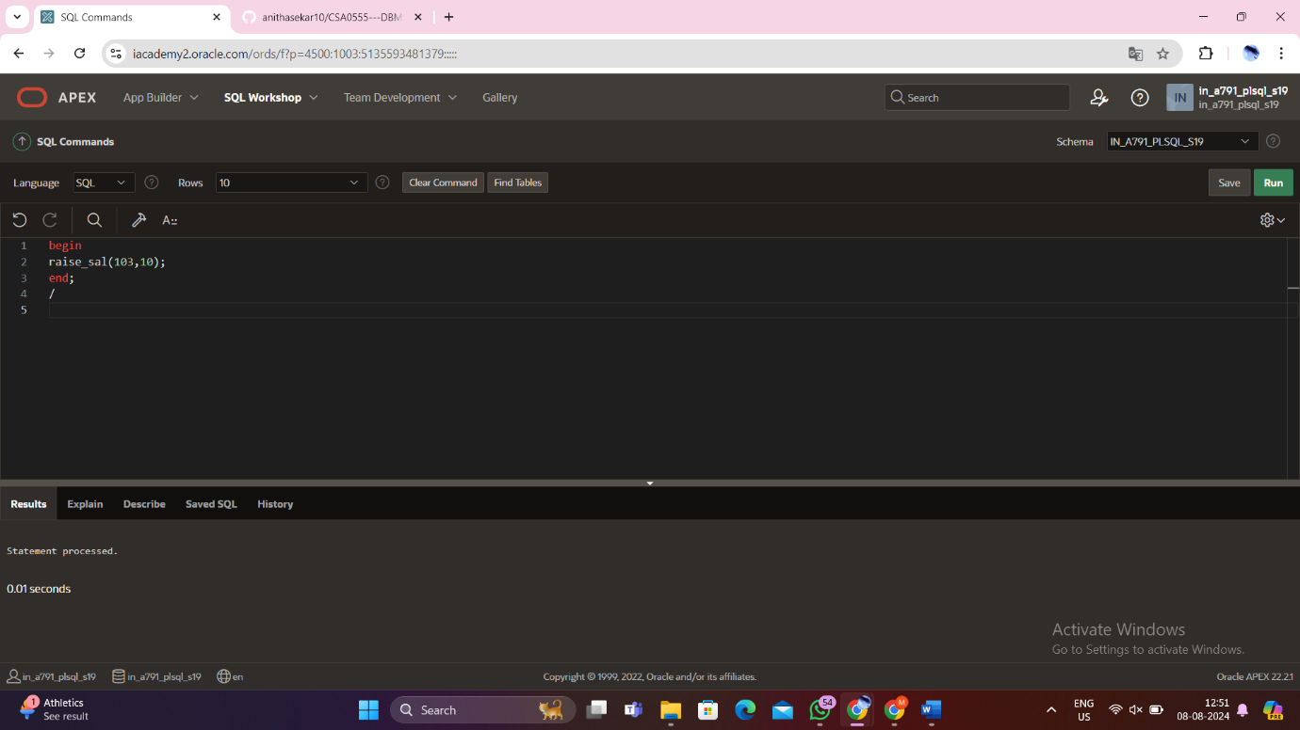

Output:

Select * from emp1;

